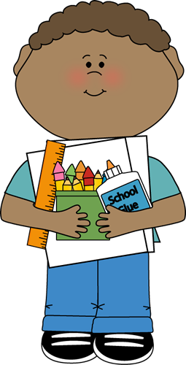

Dewey Preschool Supply List
Here are a few supplies that are needed as we begin the school year:
- 1 complete change of clothes that stays at school (pants, shorts, underwear and socks)
- Kleenex - 2 boxes
- Disinfectant wipes
- Disinfectant spray
- Hand Sanitizer (no travel size)
- Hand Soap
- Paper towels
- 1 box of Gallon sized Ziploc bags
- 1 box of Quart sized Ziploc bags
- Glue Sticks - 2
- 1 blue 2 pocket vinyl folder
- 1 yellow 2 pocket vinyl folder
- 2 packs of index cards
- 1 backpack that fits your child and carries regular sized paper
- Pencil case
- It is recommended but not required that your child wear a cloth mask each day to school

Please remember to label all backpacks, clothes, and jackets that come to school.
We look forward to a great year!


